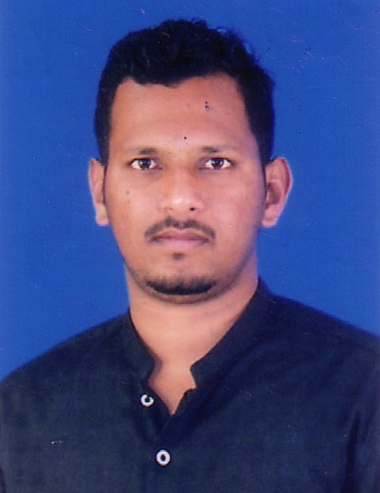

Personal Profile of Shiva Kumar M

Name | SHIVA KUMAR M
Designation | Assistant Professor of Political Science
Qualification | M.A., (Ph.D)
Subject (Specialization) | Political Science  Public Administration
Official Address | Shiva Kumar M  Assistant Professor of Political Science,  P.E.S. College of Science, Arts and Commerce, Mandya.
Residential Address | Shiva Kumar M  # 3902, 5th Cross, Gandhinagar, Mysore.
Date of Birth | 09/05/1988.
Contact Number | 9901424345.
E-mail | shvkumarm@gmail.com

Teaching Experience

Institution | Designation | Course | Year
St. Philomena’s College, Mysore | Assistant Professor | B.A., | 2010 - 2011
Maharani’s Arts & Commerce College for Women, Mysore | Assistant Professor | B.A., | 2011 - 2014
P.E.S. College of Science, Arts & Commerce, Mandya. | Assistant Professor & HOD. | B.A., | 13.01.2014  Till Date

CONFERENCE/WORKSHOP/SEMINAR/OP ATTENDED

Sl.  No. | Conferences/Seminars/ Workshop | Name of the Institute/ University | Place | Date
1. | One day State Level workshop on “Human Rights in India’’ (Concept, Issues and Policy) | Department of Studies in Political Science and Public Administration, University of Mysore in association with Karnataka State Human Rights Commission, Bangalore. | Mysore | 11th April 2011
2. | Two Day National Seminar on “Good Governance, Human rights and judiciary’’ | National Human Rights Commission, New Delhi in collaboration with the Department of studies in Political Science, University of Mysore. | Mysore | 3rd& 4th October 2011
3. | State Level Seminar on “Relevance of Gandhism” | Shanthi Arts, Science and Commerce College | Malavalli | 24th January 2012
4. | Two day UGC – SAP National Seminar on “Politics in India with Special reference to Social Exclusion | Department of studies in Political science, University of Mysore | Mysore | 28th& 29th February 2012.
5. | State Level Seminar on “Coalition Politics and Governance | Department of Political Science, Bharathi College | Maddur
6. | “India’s role in a globalized world” | Presented a paper entitled “India’s Foreign Policy”, in 15th State Level Political science teachers conference on “India’s role in a globalized world”, organized by Karnataka University Colleges Political Science teachers forum, Dharwad | Dharwad | 19th and 20th September 2014.
7 | State Level seminar on “Human Rights in Global Scenario” | JSS College for Women (Autonomous), Mysore. | Mysore | 27th September 2014
8. | Two – Day National Level Workshop on “Research Methodology and Data Analysis” | Post Graduate Department of Commerce, Teresian College, Mysore. | Mysore | 11th and 12th November, 2014
9. | Two - day International Conference on Ethnicity, Discrimination and social exclusion of minorities and margins: Post-colonial debates | Centre for study of Social Exclusion and Inclusion Policy (CSSEIP), University of Mysore | Mysore | 18th and 19th December 2014
10. | Participated in 106th Orientation Programme | Academic staff college, University of Mysore, Mysore. | Mysore | 24th Dec 2014 to 20th January 2015 ( 24 days programme)
11. | State Level seminar on Media And Society, Conference About Freedom Of Expressions | Government Women’s College, Mandya, District Working Journalist Association, Mandya | Mandya | 9th April 2015
12 | One day International Conference on “Changing role of education in the field on Commerce, Social Science and Management” | Presented a paper entitled “Domestic politics of India’s Foreign policy in a Globalised World”, in 2nd International Conference Organized by Indo Global Chamber of commerce, Industries and Agriculture | Pune | 24th February, 2016
13 | 2nd International conference on Education &Leadership Summit (IELS) | Presented a paper entitled “Role of NGO’s in Social Reforms”, Indo Global Chamber of commerce, Industries and Agriculture | Pune | 2016
14 | One Day State Level Seminar organised by the Department of Political Science | “Democratic Decentralization And Inclusive Development: Issues and challenges for the Third Decade of Panchayath Raj in India | Mandya | 17th of February 2017.
15 | Published a Research Article in International Journal of Research and Analytical Reviews (IJRAR) | “The Lok Sabha Elections in Karnataka in 2014 An Analysis” in UGC and ISSN Approved International Journal of Research and Analytical Reviews (IJRAR) Volume-5  E-ISSN 2348-1269 |  | 2018
16 | One Day State Level Webinar Organised by the Department of Political Science | “ Realising One Nation One Constitution in Multicultural India- Problems and Prospectus” |  | 28th October 2020
17 | One Day International Level Webinar Organised by the Department of Political Science | “Covid-19 Vaccine Internationalism Challenges and Opportunities” |  | 04th November 2020
Orientation Programme/ Refresher Course

Sl. No | Programme | Organised By | Duration
1 | 106th Orientation Programme | University of Mysore, Mysore | 24/12/2014  To  20/01/2015  (24 Days)
2 | 1st Refresher Course in Political Science & Public Administration. | UGC- HRDC, Mysore | 11/01/2018  To  31/01/2018  (28 Days)

BOE MEMBER
Sl. No | Name of the Institution | Duration
1 | St. Philomena’s College (Autonomous), Mysuru | 2018-2020.

Membership in Professional Societies:
Sl. No. | Details
 | Life member Karnataka State Political Science Teachers Association.
 | Life member Karnataka State Political Science Association, Mysore. (KAPSA)

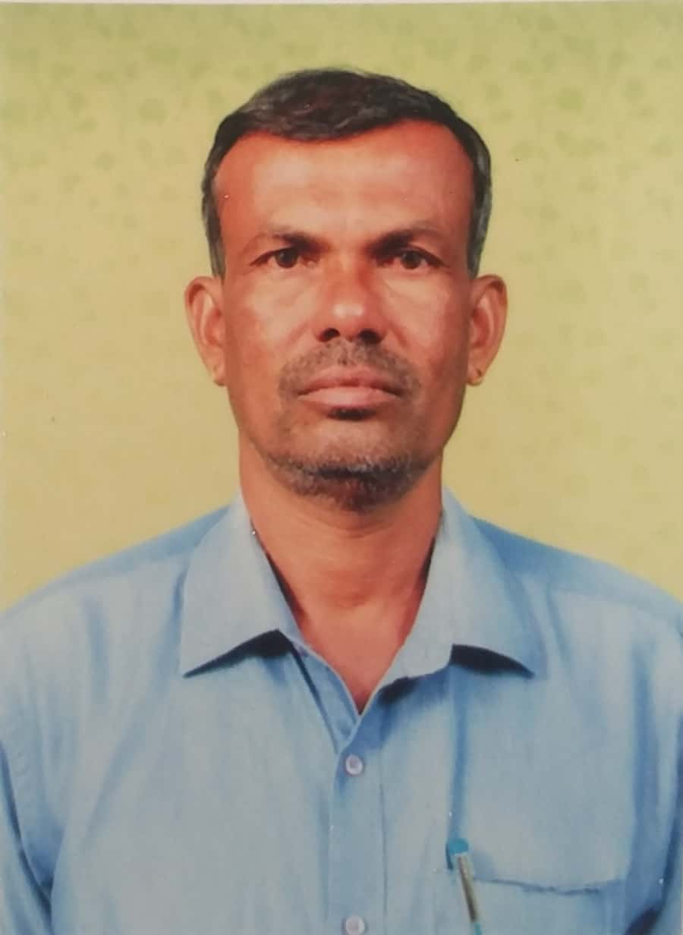
Personal Profile of K.N. Jogigowda

Name | K.N. Jogigowda
Designation | Assistant Professor
Qualification | M.A., M.Phil
Subject (Specialization) | Political Science  Political Theory
Official Address | K.N. Jogigowda  Assistant Professor of Political Science,  P.E.S. College of Science, Arts and Commerce, Mandya.
Residential Address | K.N. Jogigowda  S/o Ninganna, Kurikoppalu, Chandagalu (P), Dudda (H), Mandya (T) & (D)
Date of Birth | 03/02/1969
Contact Number | 9945995279
E-mail | knjogigowda@gmail.com

Teaching Experience

Institution | Designation | Course | Year
P.E.S. College of Science, Arts & Commerce | Assistant Professor | B.A., | 2000–Till Date

CONFERENCE/WORKSHOP/SEMINAR/OP ATTENDED

Sl.  No. | Conferences/Seminars/ Workshop | Name of the Institute/ University | Place | Date
1 | One day State Level Seminar on ‘Crisis in sugar Industry & famers Suicide’ | Bharathi College | Maddur | 9th May 2009
2. | Two day 11th State Level Political Science teachers conference | University of Mysore | ManasaGangotri | 29th& 30th Dec 2009
3. | “ Women’s rights in context of human rights’’ | PES College of Science | Mandya | 6th Nov 2009
4 | One Day State Level Seminar on “Democratic Decentralization And Inclusive Development: Issues and challenges for the Third Decade of Panchayath Raj in India | PES College of Science | Mandya | 17th Feb 2018

Membership in Professional Societies:

Sl. No. | Details
 | Life member Karnataka State Political Science Teachers Association Karnataka State Open University, Mysore.

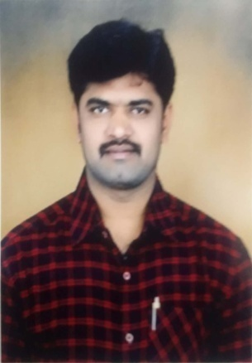Personal Profile of Sathisha H.N

Name | SATHISHA H.N
Designation | Assistant Professor
Qualification | M.A., M.Phil., (Ph.D)
Subject (Specialization) | Political Science  International Relations
Official Address | Sathisha H.N  Assistant Professor of Political Science,  P.E.S. College of Science, Arts and Commerce, Mandya.
Residential Address | Sathisha H.N  S/o Nagaraju S, Hombalegowdana Doddi,  Maddur (Tq), Mandya.
Date of Birth | 18/07/1981.
Contact Number | 9743114324.
E-mail | minchu81@gmail.com

CONFERENCE/WORKSHOP/SEMINAR/OP ATTENDED

Sl.  No. | Conferences/Seminars/ Workshop | Name of the Institute/ University | Place | Date
1. | One day Regional Level workshop on “Achieving Excellence in Teaching & Administration” | Government College (Autonomous) | Mandya | 8th March 2014.
2. | One day State level Seminar on “Challenges in Higher Education’’ | Government College (Autonomous) | Mandya | 7th May 2015.
3. | One day National Level Seminar on “Democratic Governance in India: Problems & Prospects” | Department of studies in Political science, University of Mysore | Mysore | 10th December 2015.
4. | Two day UGC – SAP National Seminar on “Politics in India with Special reference to Social Exclusion | Department of studies in Political science, University of Mysore | Mysore | 28th& 29th February 2012.
5 | One Day State Level Seminar organised by the Department of Political Science | “Democratic Decentralization And Inclusive Development: Issues and challenges for the Third Decade of Panchayath Raj in India | Mandya | 17th of February 2017.

Special Lectures Delivered:
- Government first grade College Koppa on the Topic entitled “Indian Political Thought” in 2015.
- Bharathi College, Kirugavalu on the Topic entitled “Recent Trends in Democracy” in 2016.
- Government first grade college K.R Pet on the Topic entitled “Research Methodology” in 2017.
- Bharathi College, Bharathi Nagar on the Topic entitled “Empowerment of Local Government” in 2018.

